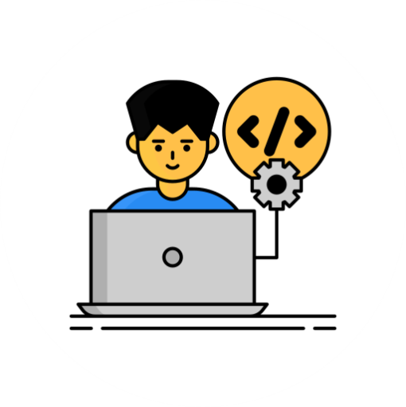

**LINGARAJ P**



EXPERIENCE

**FRONTEND DEVELOPER**

I have 3years experience in Frontend Development as a Freelancer.

**2017 - 2020**

Freelancer,

Erode.

**CONTACT ME**

[](https://www.facebook.com/linga.rock/)[](https://twitter.com/Lingaraj_1995)

**JAVASCRIPT**

**HTML5 , CSS3**

**REACT JS**

**CORE JAVA**

**SOFTWARE TRAINING**

I attended a Java & Python Programming Language Training at National Small Industries Corporation, Chennai.

**Or**

**PRO SKILLS**

**GITHUB**

**FOLLOW ME**

**Address**

S/O Periyasamy and Samundeeswari , Sengottai Nagar, Sathyamangalam(TK), Erode(DT), Tamil Nadu,

PIN:638401.

**Phone**

+91 9585183914

+91 8610553070

**Web**

[lingarajsvhec46@gmail.com](mailto:lingarajsvhec46@gmail.com)

**Twitter**

twitter.com/Lingaraj_1995

**Facebook**

facebook.com/linga.rock/

**2006 - 2010**

State Board

**2010 - 2012**

State Board

**B.E(ECE) – 63%**

I studied a B.E Electronics and Communication Engineering at Shree Venkateshwara Hi-Tech Engineering College, Gobichettipalaiyam.

**SSLC – 89%**

I studied a SSLC at Government Higher

Secondary School, DasappagoundenPudur.

.

**HSC – 70%**

I studied a HSC at St. Francis Xavier’s Higher Secondary School, Periyakodeveri.

**March 2021 - Sep 2021**

National Small Industries Corporation, Chennai.

Please Scan a QR

Code

Please Click On The

Web Image

PROJECTS & ONLINE - PORTFOLIO

EDUCATION

SOFTWARE TRAINING

**2012 - 2016**

Anna University,

Chennai.